MIT 565 – Internetworking
Final Project Documentation
Gaurishankar Bikram Jirel · Elmhurst University · Spring 2026
Network Design Overview

This network architecture consists of three branch locations—Chicago, New York, and Indiana—interconnected through a central router, RouterHub (Router6). The design incorporates multiple routing protocols to demonstrate interoperability in a hybrid routing environment.

The Chicago and New York branches utilize the OSPF (Open Shortest Path First) dynamic routing protocol for internal route advertisement and path selection. In contrast, the Indiana branch operates using the EIGRP (Enhanced Interior Gateway Routing Protocol) to distribute its routing information.

To enable seamless communication between these different routing domains, RouterHub is configured with route redistribution, allowing it to exchange routing information between OSPF and EIGRP. This ensures full network reachability across all branches despite the use of different routing protocols.

IP Addressing Scheme

Each branch network is logically segmented using VLANs to improve network organization, performance, and security.

Chicago Branch:
VLAN 10: 192.168.10.0/24
VLAN 20: 192.168.20.0/24
VLAN 30: 192.168.30.0/24
New York Branch:
VLAN 10: 192.168.12.0/24
VLAN 20: 192.168.22.0/24
VLAN 30: 192.168.32.0/24
Indiana Branch:
VLAN 10: 192.168.11.0/24
VLAN 20: 192.168.21.0/24
VLAN 30: 192.168.31.0/24

Inter-router communication is established using point-to-point links with /30 subnetting to optimize IP address utilization:

Chicago ↔ RouterHub: 10.0.16.0/30
Indiana ↔ RouterHub: 10.0.17.0/30
New York ↔ RouterHub: 10.0.18.0/30
Security and Access Control

To enforce internal network security policies, Access Control Lists (ACLs) are implemented at the branch level.

At the Chicago branch, an extended ACL is configured on interface GigabitEthernet0/0/0 to restrict communication between departments. Specifically, devices in the HR VLAN are denied access to the IT VLAN, ensuring sensitive departmental data remains isolated.

This approach enhances security by controlling inter-VLAN traffic and limiting unauthorized access while still allowing permitted communications within the network.

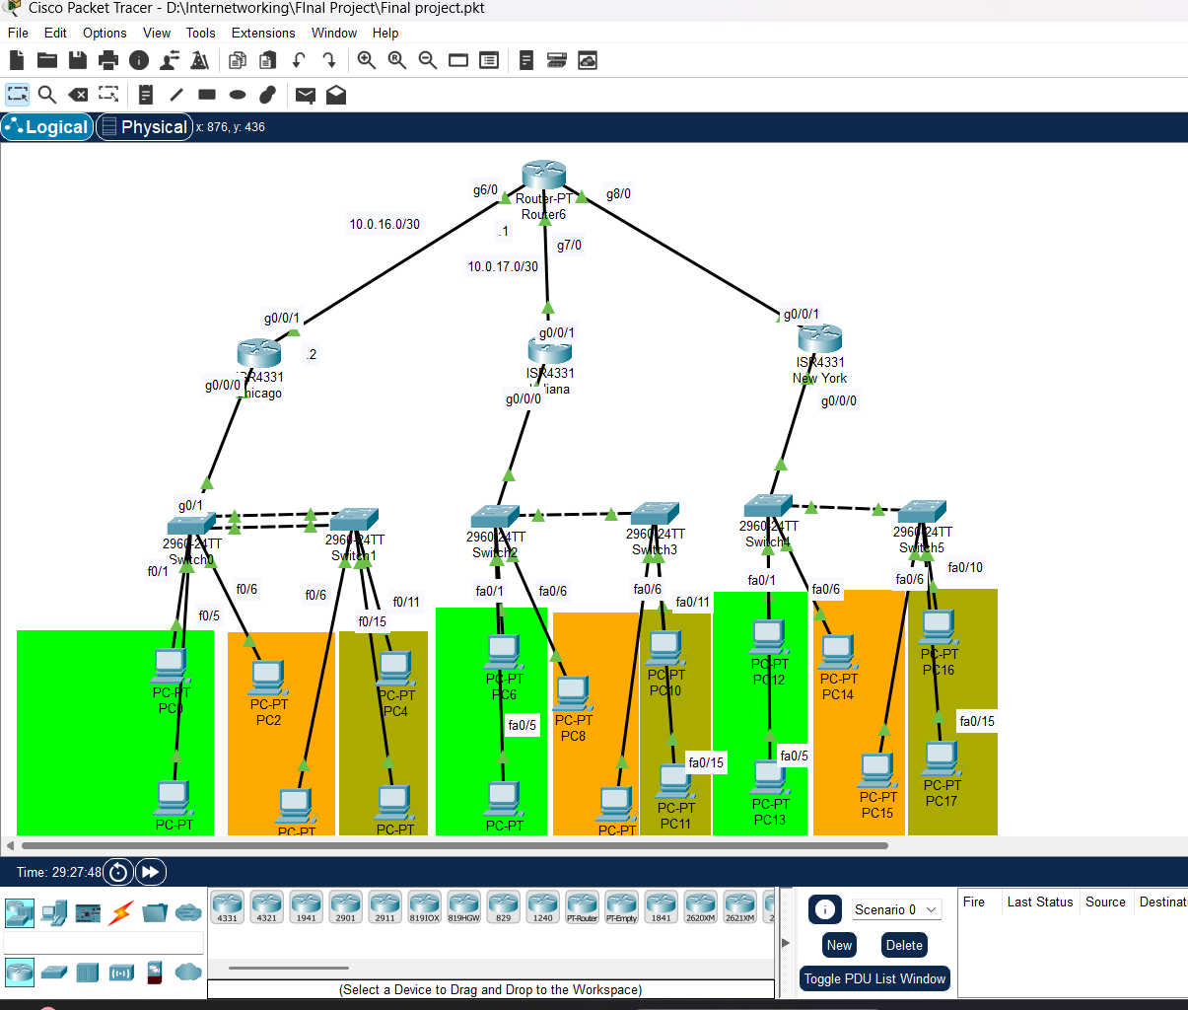

1. Chicago Branch

1.1 Chicago Router
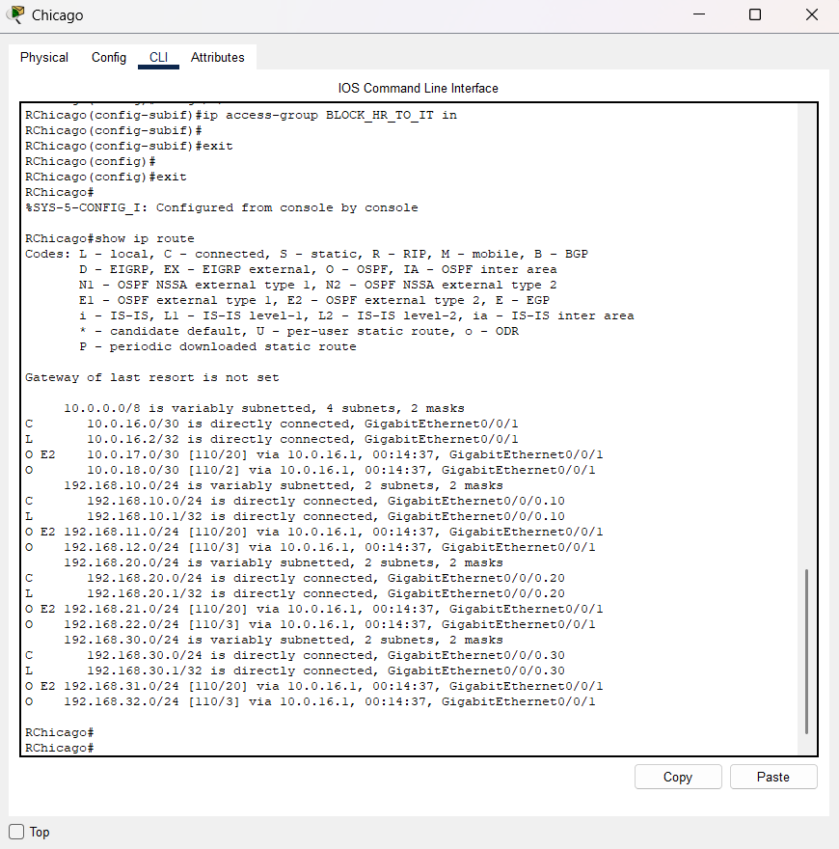 [ Insert Screenshot Here ]
Right-click → Change Picture or drag & drop image onto this frame
Figure 1.1 – Chicago Router: Running Configuration
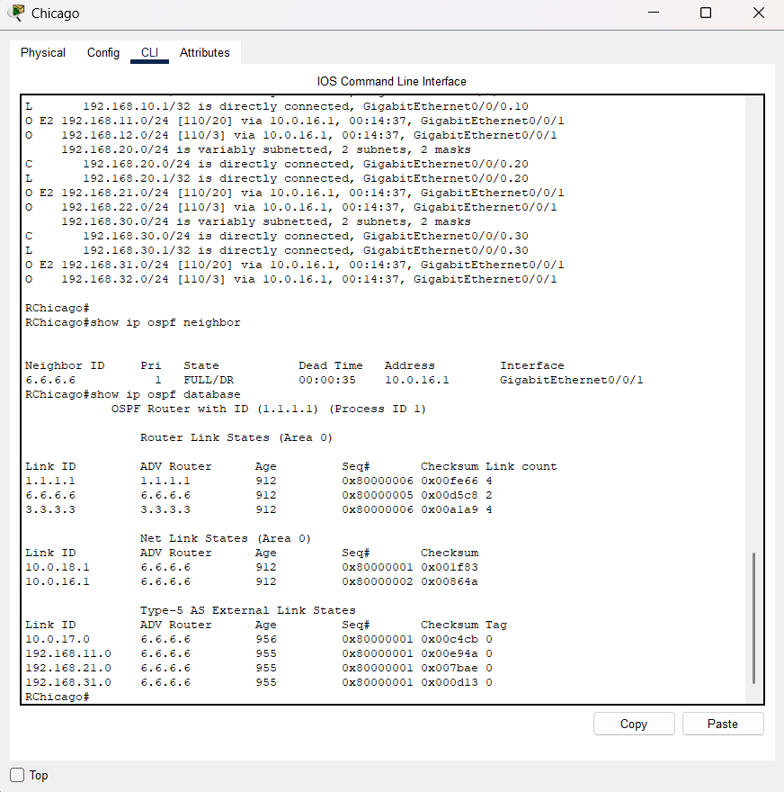 [ Insert Screenshot Here ]
Right-click → Change Picture or drag & drop image onto this frame
Figure 1.1 – Chicago Router: Running Configuration

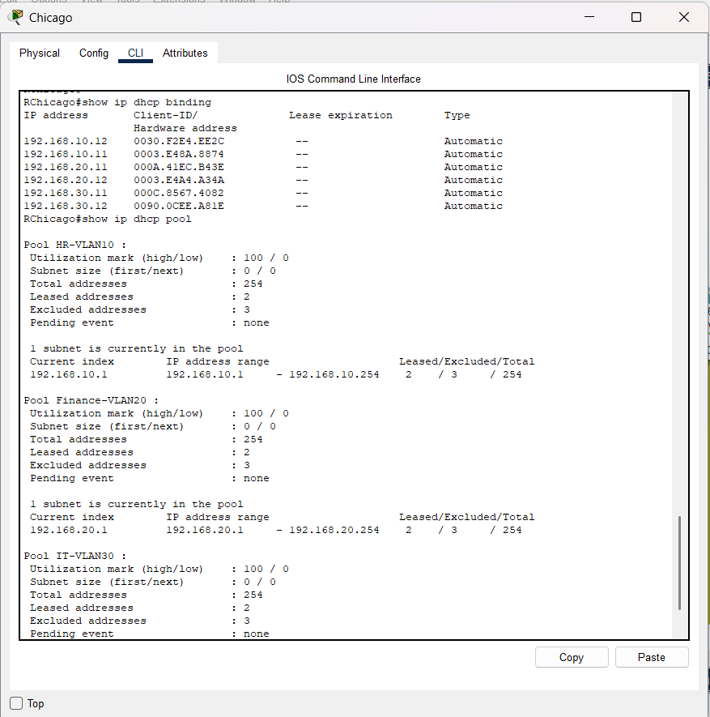 [ Insert Screenshot Here ]
Right-click → Change Picture or drag & drop image onto this frame
Figure 1.1 – Chicago Router: Running Configuration

1.2 Access Control List (ACL)
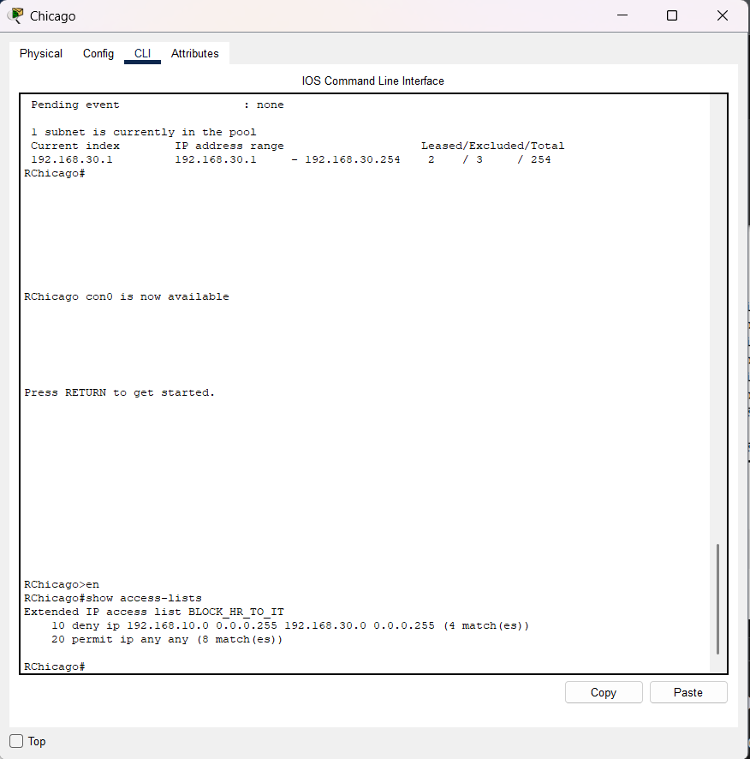 [ Insert Screenshot Here ]
Right-click → Change Picture or drag & drop image onto this frame
Figure 1.2a – Chicago Router: ACL Configuration

1.3 Chicago Switches

Spanning Tree Protocol
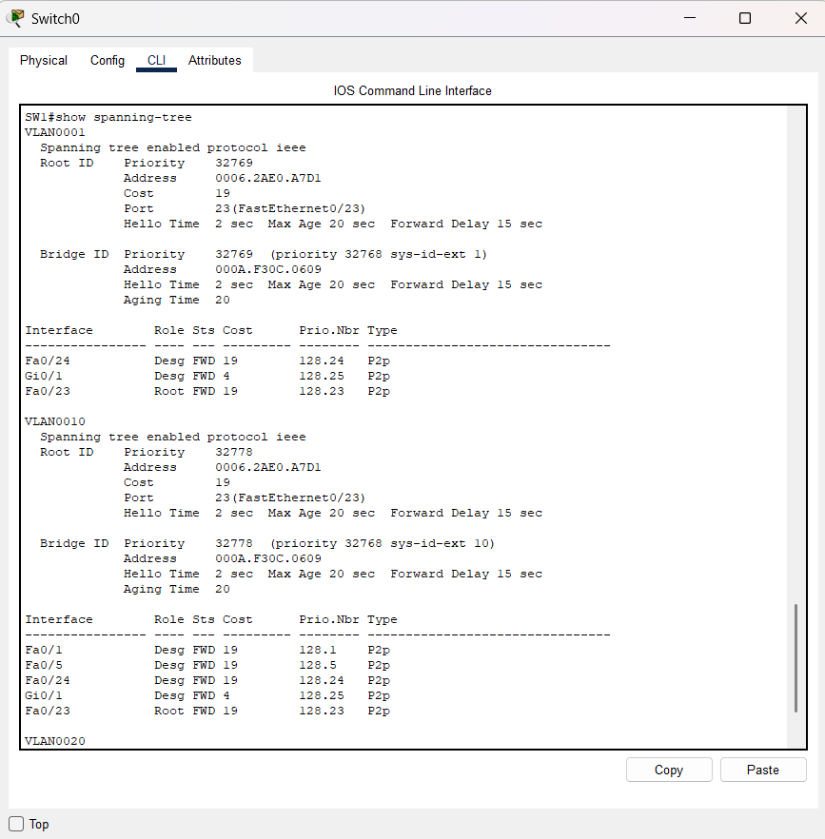 [ Insert Screenshot Here ]
Right-click → Change Picture or drag & drop image onto this frame
Figure 1.3a – Chicago Switch: Spanning Tree Verification (show spanning-tree)

Port Security and EtherChannel
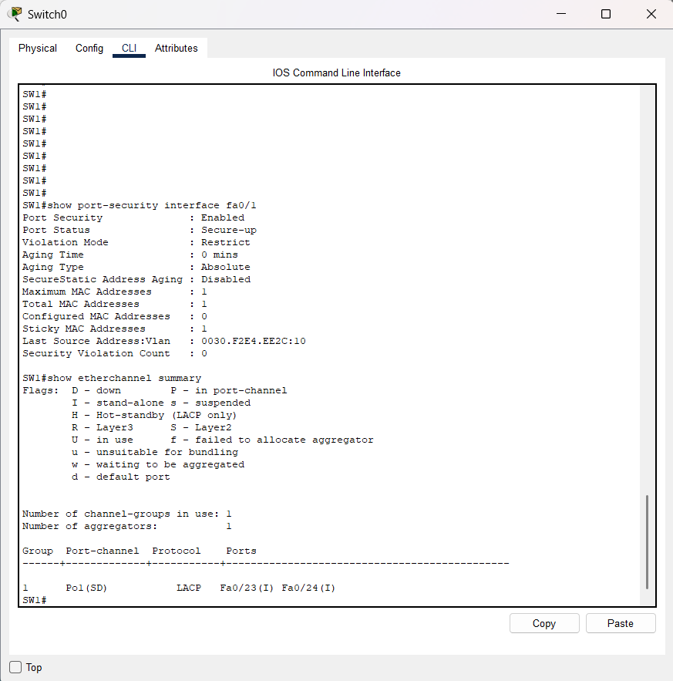 [ Insert Screenshot Here ]
Right-click → Change Picture or drag & drop image onto this frame
Figure 1.3b – Chicago Switch: Port Security & EtherChannel Verification

1.4 Pings from PC in Chicago Branch
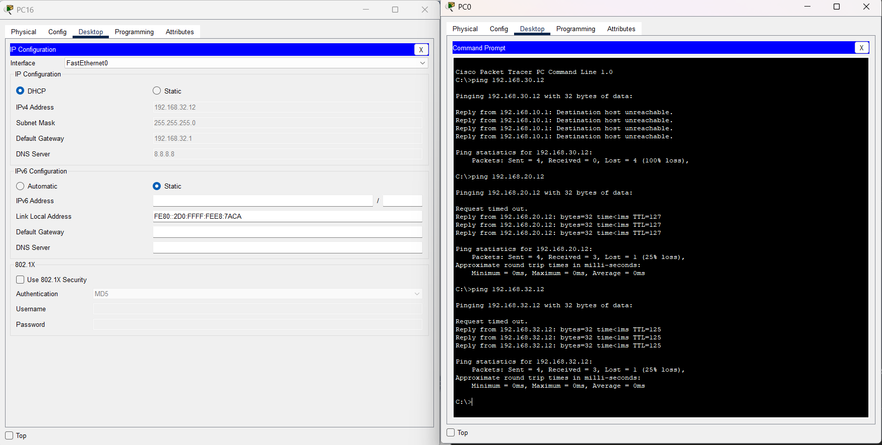 [ Insert Screenshot Here ]
Right-click → Change Picture or drag & drop image onto this frame
Figure 1.4 – Chicago Branch: Ping Test Results

2. Indiana Branch

2.1 Routing
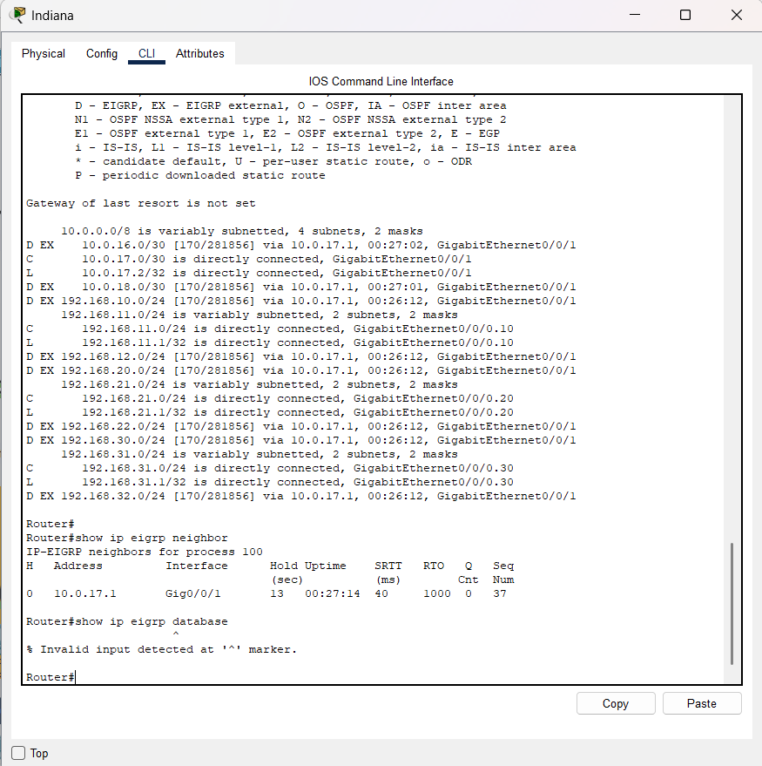 [ Insert Screenshot Here ]
Right-click → Change Picture or drag & drop image onto this frame
Figure 2.1a – Indiana Router: Running Configuration / EIGRP Verification

[ Insert Screenshot Here ]
Right-c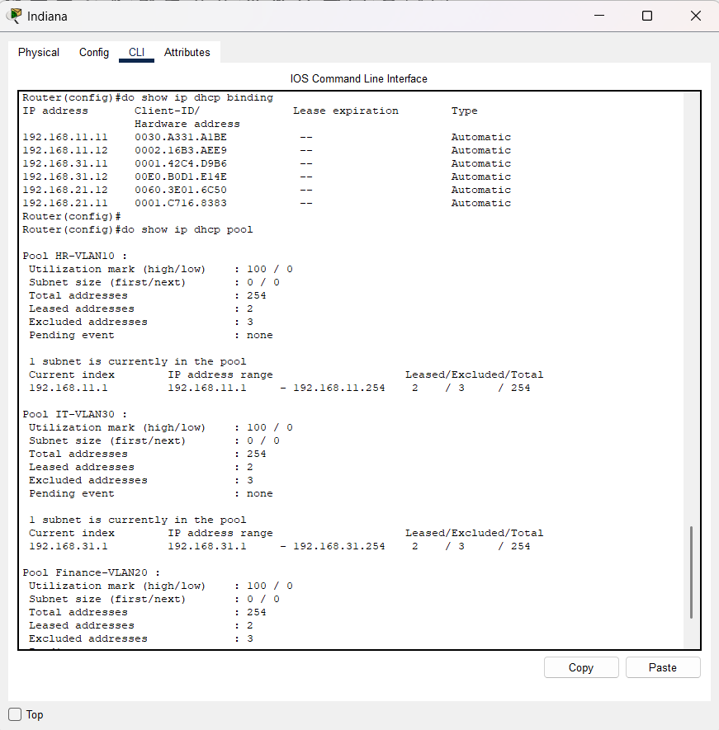lick → Change Picture or drag & drop image onto this frame
Figure 2.1b – Indiana Router: Routing Table (dhcp)

2.2 Indiana Switches
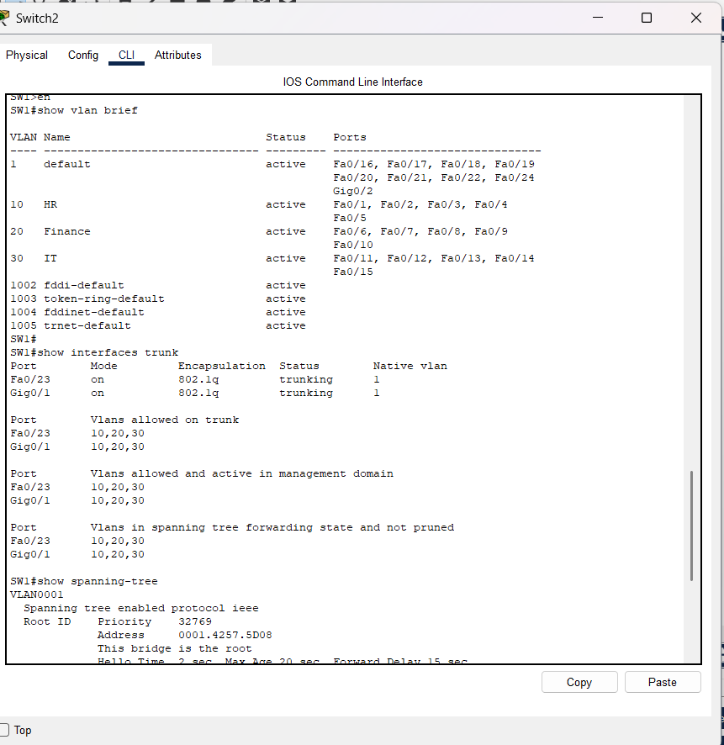 [ Insert Screenshot Here ]
Right-click → Change Picture or drag & drop image onto this frame
Figure 2.2a – Indiana Switch: VLAN & Trunk Configuration

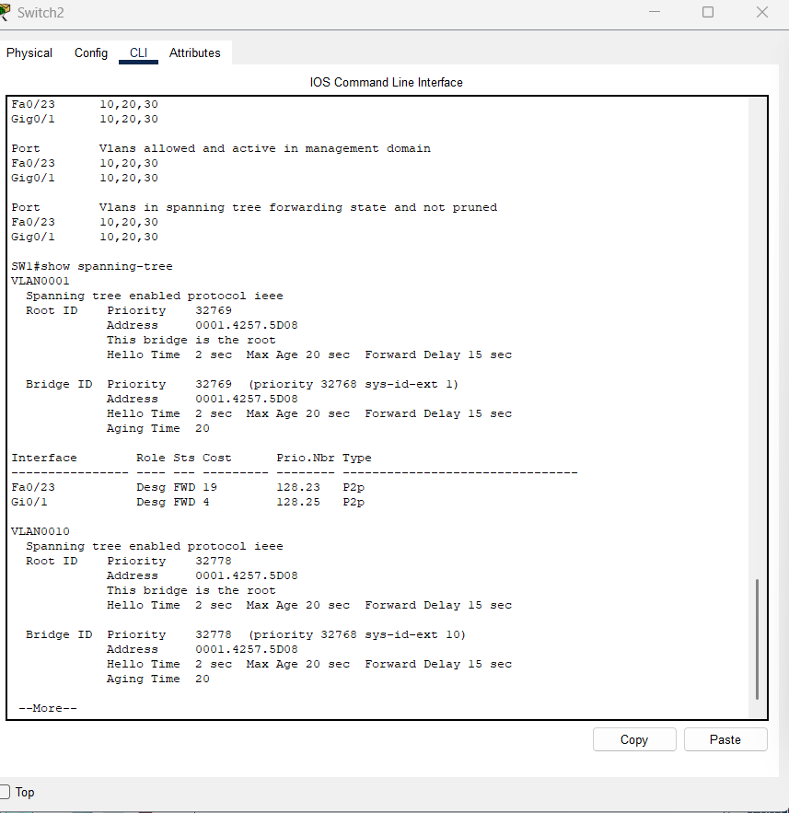 [ Insert Screenshot Here ]
Right-click → Change Picture or drag & drop image onto this frame
Figure 2.2b – Indiana Switch: Spanning Tree Verification

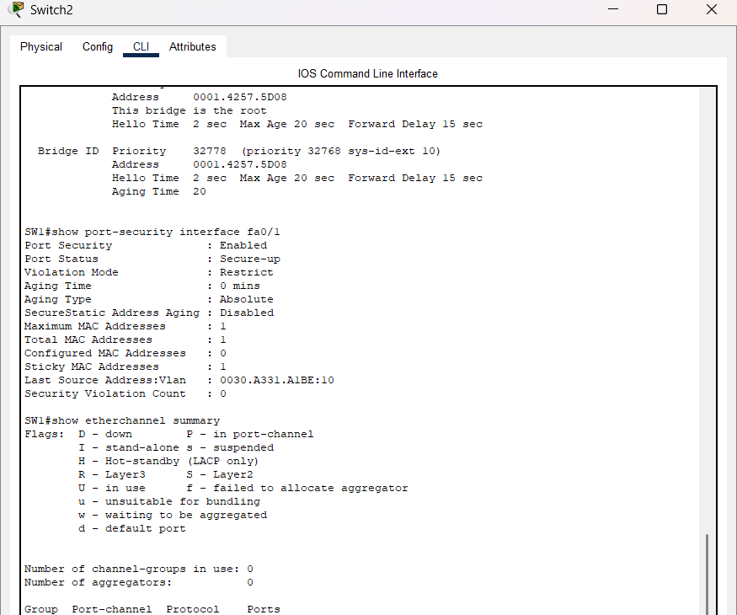
Right-click → Change Picture or drag & drop image onto this frame
Figure 2.2c – Indiana Switch: Port Security & EtherChannel

2.3 Pings from PCs in Indiana Branch
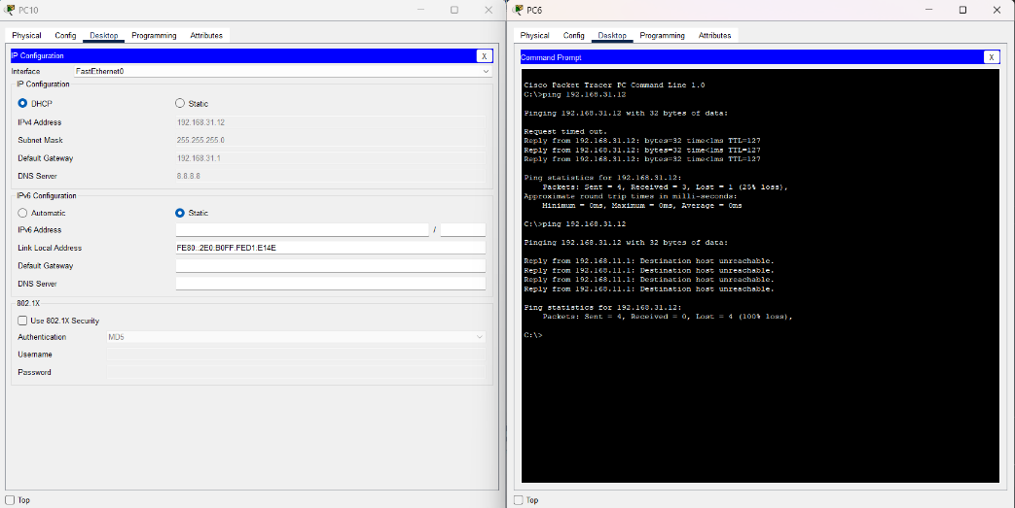
Figure 2.3 – Indiana Branch: Ping Test Results

3. New York Branch

3.1 Routing
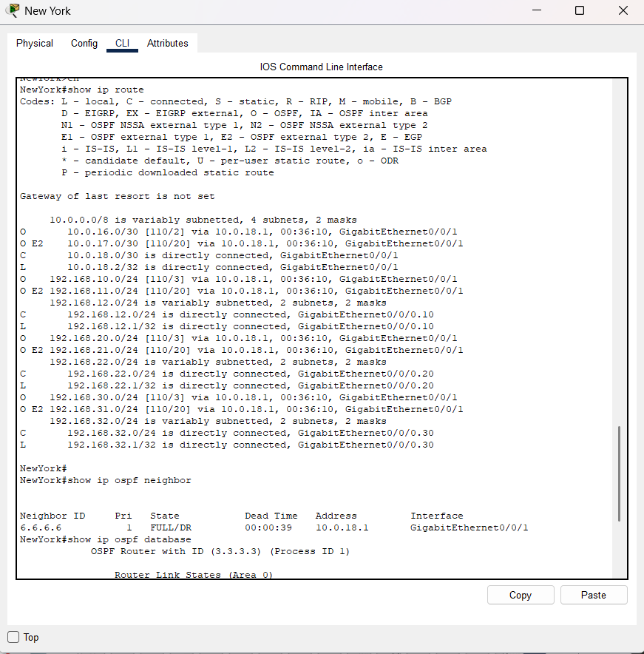
Figure 3.1a – New York Router: Running Configuration

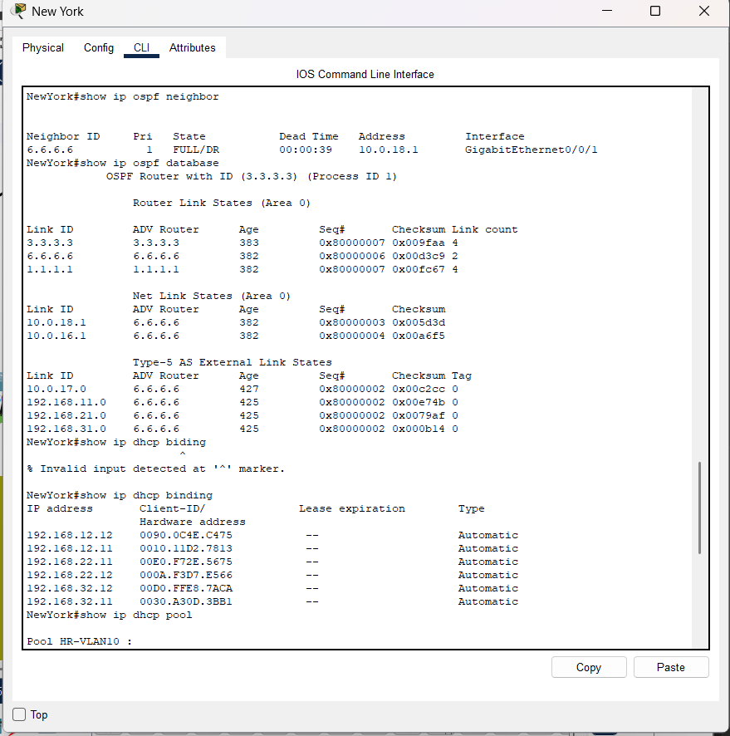
Figure 3.1b – New York Router: OSPF Verification (show ip ospf neighbor)

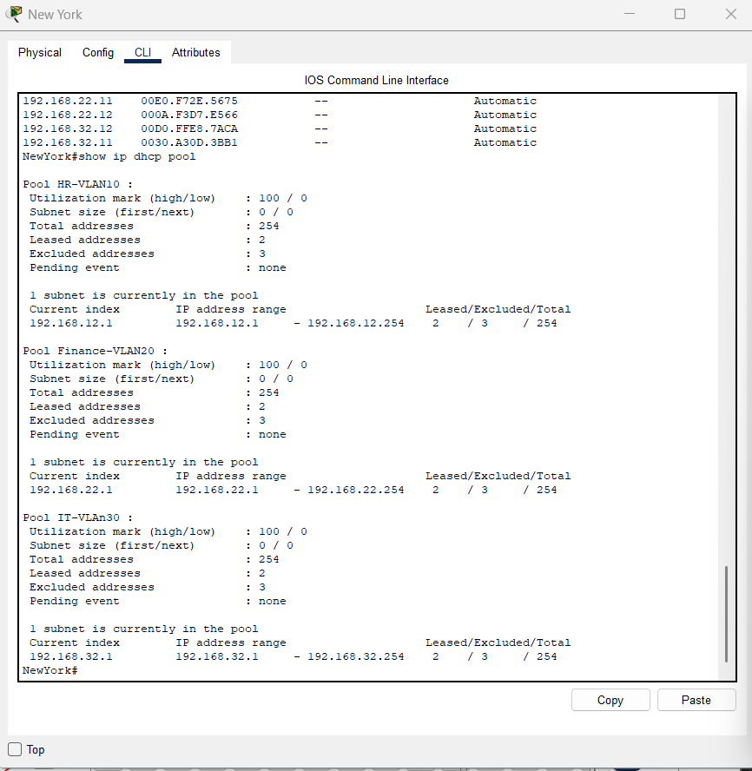
Figure 3.1c – New York Router: Routing Table (dhcp pool)

3.2 New York Switches
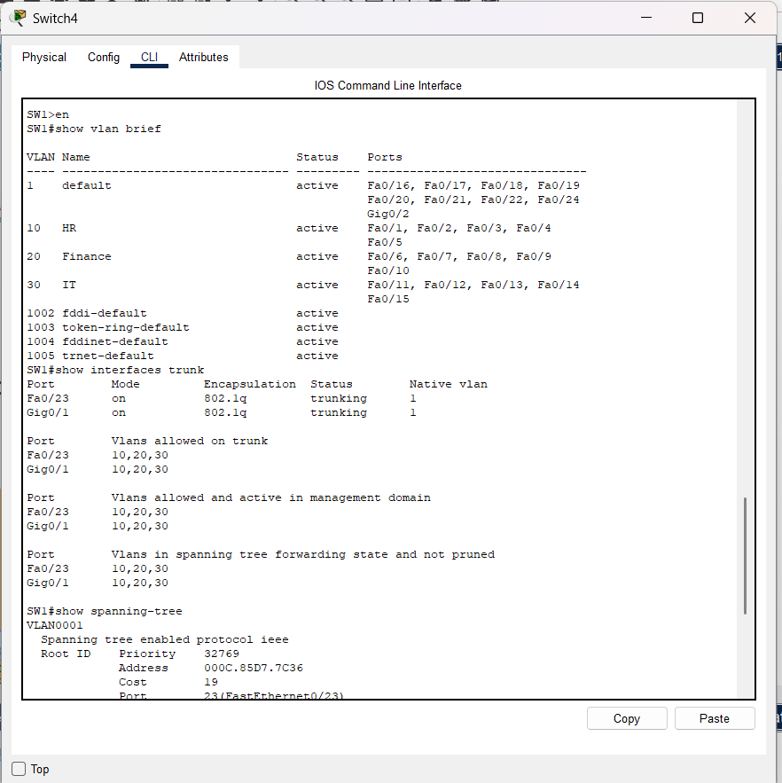
Figure 3.2a – New York Switch: VLAN & Trunk Configuration

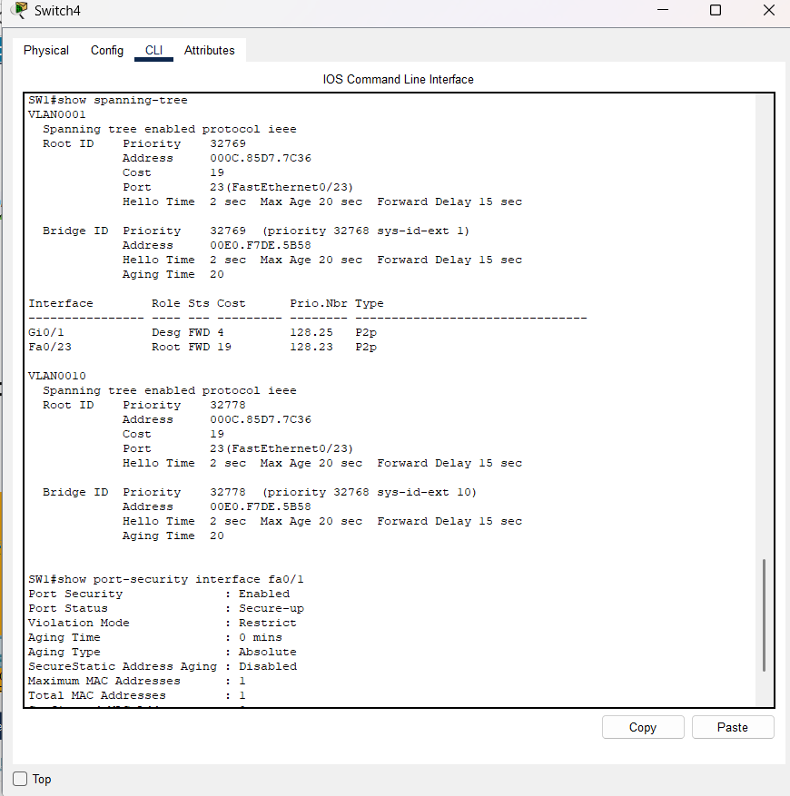

Figure 3.2b – New York Switch: Spanning Tree & Port Security

3.3 Pings from PC in New York
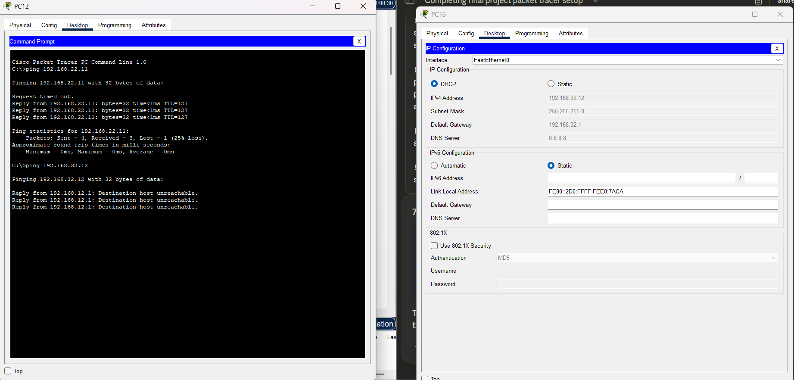

Figure 3.3 – New York Branch: Ping Test Results

4. CoreHUB Router – Connects All Branches

4.1 Routing
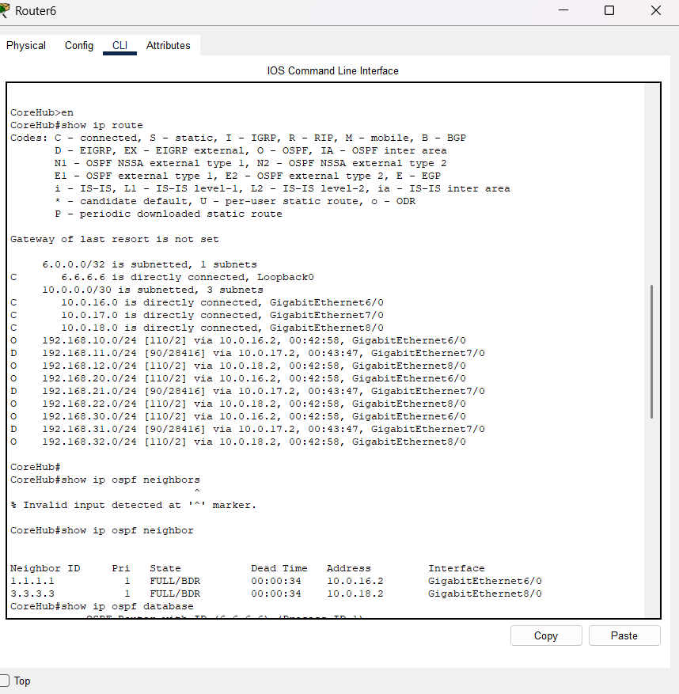

Figure 4.1a – CoreHUB Router: Routing Table (show ip route)

